PROJECT REPORT ON
“Online Learning Behaviour”
IN PARTIAL FULFILLMENT OF
BACHELOR OF COMPUTER SCIENCE
SEMESTER 2025-26
SUBMITTED BY: Dhanashri Ananda Achare
ROLL NO:5254

This is to verify that Miss.Dhanashri Ananda
Achare of BSC CS Semester IV has completed the project work in the Subject of Introduction of Data Science
during the academic year 2025-26 under the guidance of Prof.Sanjana Bhangale being the partial requirement for the fulfillment of the curriculum of Bachelor of Computer Science University of Mumbai

Place:

Date:

Name of the Signature of faculty Name &Signature of external

Title :Online Learning Behaviour
Dataset Description
The dataset provides information about 105 learners engaging in online education. It captures a wide range of variables including demographic data (Gender, Age), behavioral patterns (Study Hours, Number of Courses), and qualitative feedback (Platform satisfaction, Internet quality).
This project aims to explore the relationship between study habits and student satisfaction, identifying how different learning modes and internet access affect the overall learning experience.
The dataset contains 105 entries with 13 initial columns:
- Gender: Male or Female (Categorical)
- Age: Age brackets of learners (Categorical)
- Platform: Primary platform used, e.g., YouTube, Udemy (Categorical)
- Subjects: Area of study (Categorical)
- Mode: Learning style, e.g., Visual, Auditory (Categorical)
- Internet: Quality of internet access (Categorical)
- StudyHours: Weekly time spent on study (Categorical/Numeric)
- Courses: Number of courses enrolled (Categorical/Numeric)
- Rating: Satisfaction level from 1 to 5 (Categorical/Numeric)
- Doubts: Average doubts per week (Categorical/Numeric)
- Motivation: Reason for learning (Categorical)
- DoubtMethod: How doubts are resolved (Categorical)
- ObsDate: Date of survey response (Date/Time)
Project Objectives & Methodology
The project was executed in a Jupyter Notebook using Python’s pandas and numpy libraries. The analysis was divided into three levels:
- Basic (Easy): Data cleaning, column standardization, and simple filtering of demographics.
- Intermediate (Moderate): Converting textual categories (e.g., "5-10 hours") into numeric averages for mathematical analysis. Creating new metrics like the Study_Intensity_Score.
- Advanced: Identifying correlations between study time and satisfaction, and performing time-based analysis on survey responses.

Data Analysis Questions:
- Data Loading & Inspection
1)Load the dataset into a Pandas DataFrame.
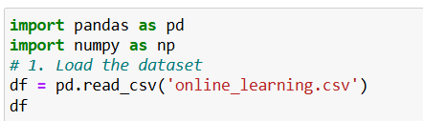
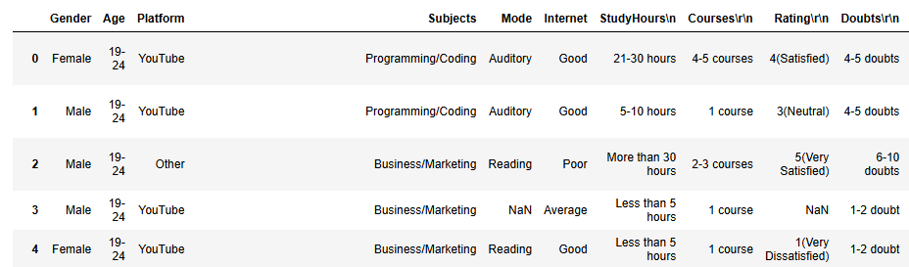

2)Display the first 5 rows of the dataset.
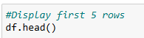
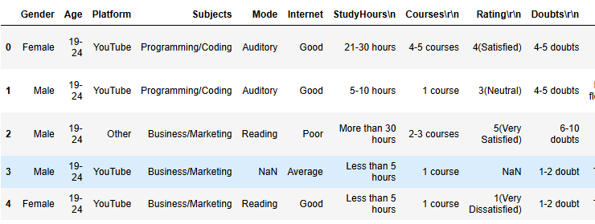

3)Display the total number of rows and columns.
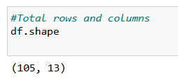

4) Print all column names.
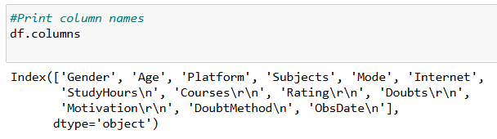

5)Check data types of each column.
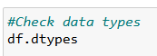
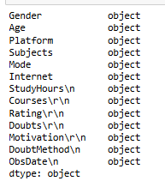

6)Identify columns with missing values.
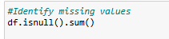
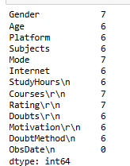

- Basic Filtering
7) Filter all Female respondents.
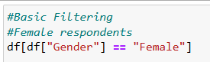
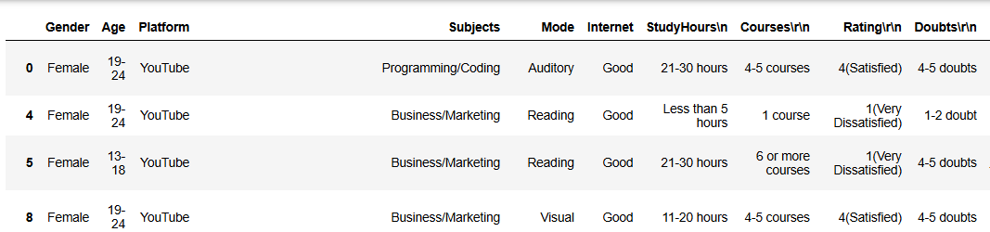

8)List respondents in the 19–24 age group.
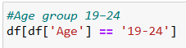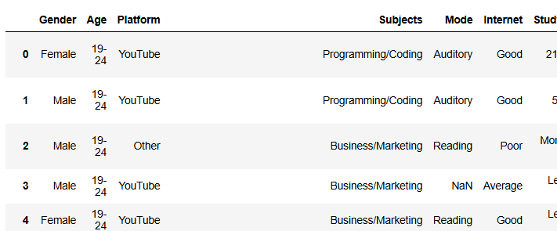

9)Show respondents who prefer YouTube as their learning platform.
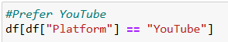
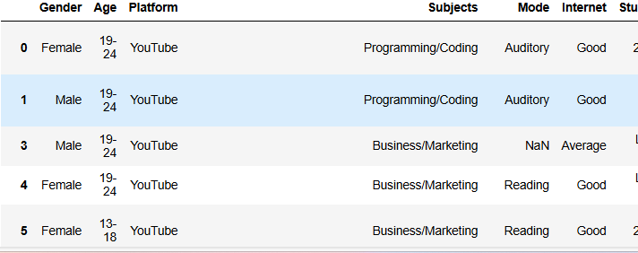

10)Filter respondents who spend More than 30 hours on online study per week.
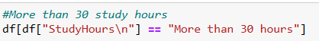
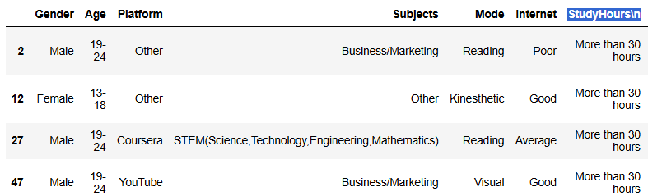

11) List learners who are enrolled in only 1 course.
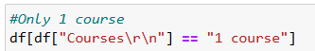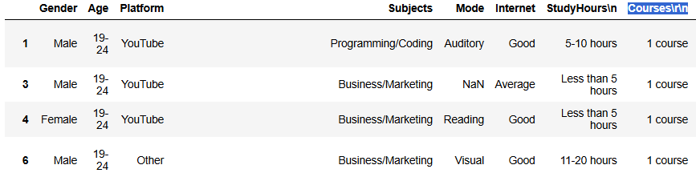

- Frequency & Counts
12)Count how many respondents prefer each online learning platform.
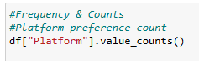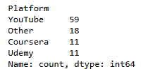

13)Find the most common subject preference.
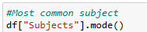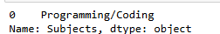

14)Count the number of respondents by type of learner (Visual, Auditory, Reading, Kinesthetic).
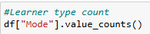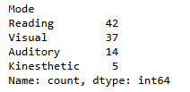

15)Count how many respondents rated their internet access as Good.
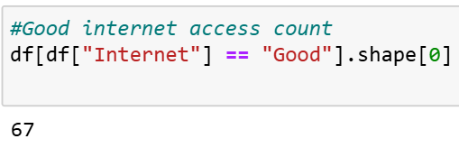

- MODERATE LEVEL QUESTIONS
- Text & Numeric Cleaning
16) Convert hours spent on online study per week into numeric values:
• Less than 5 hours
• 5–10 hours
• 11–20 hours
• 21–30 hours
• More than 30 hours
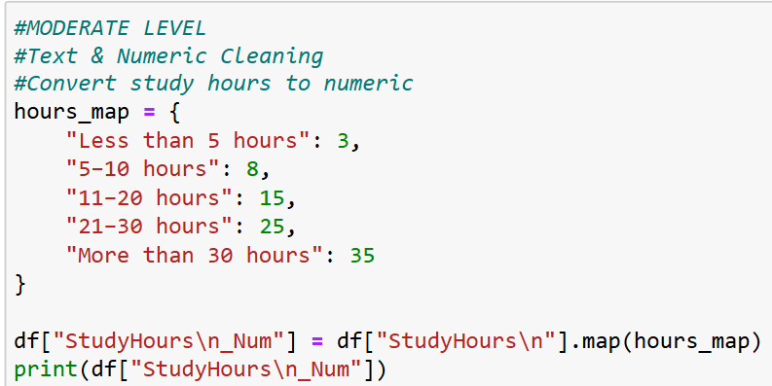
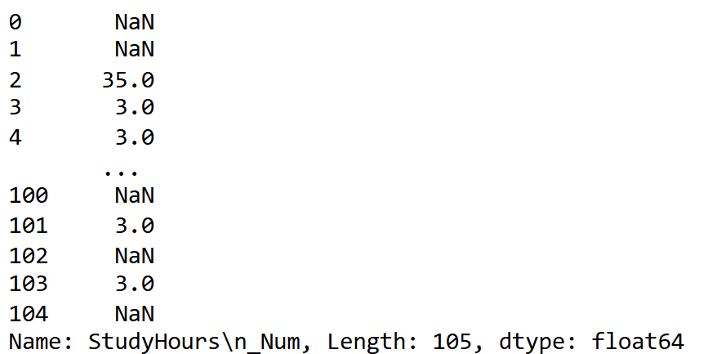

17)Convert number of online courses enrolled into numeric values:
• 1 course
• 2–3 courses
• 4–5 courses
• 6 or more courses
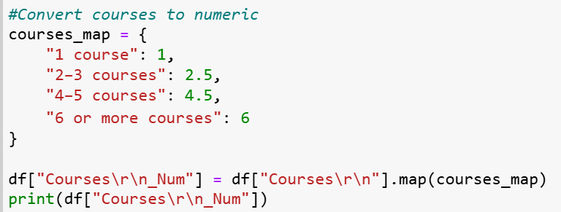
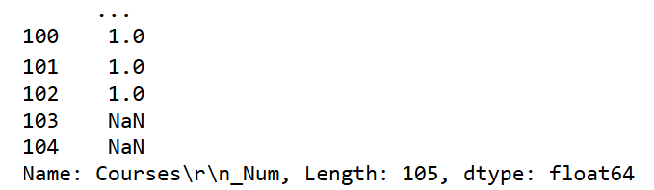

18)Extract numeric rating from:
• 4(Satisfied)
• 3(Neutral)
• 1(Very Dissatisfied)
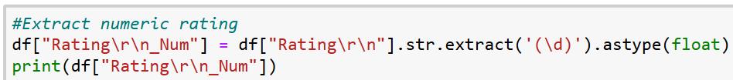
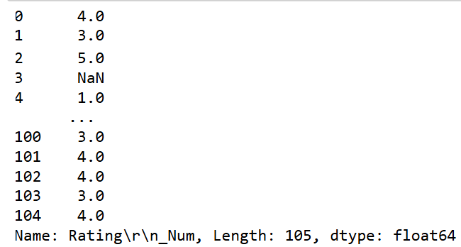

19)Convert number of doubts per week into numeric averages:
• 1–2 doubt
• 4–5 doubts
• More than 10 doubts
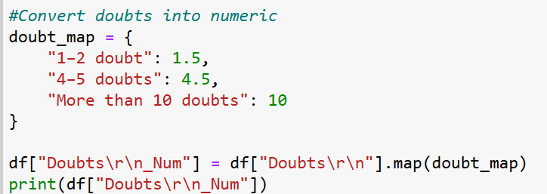
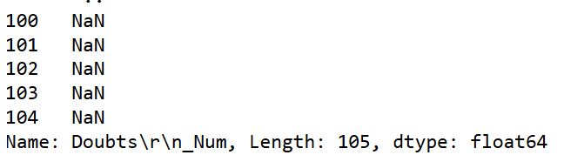

20) Standardize inconsistent text values (e.g., doubt vs doubts, missing learner types).
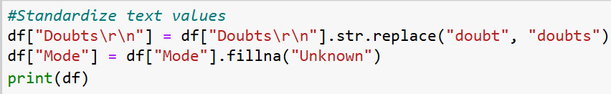
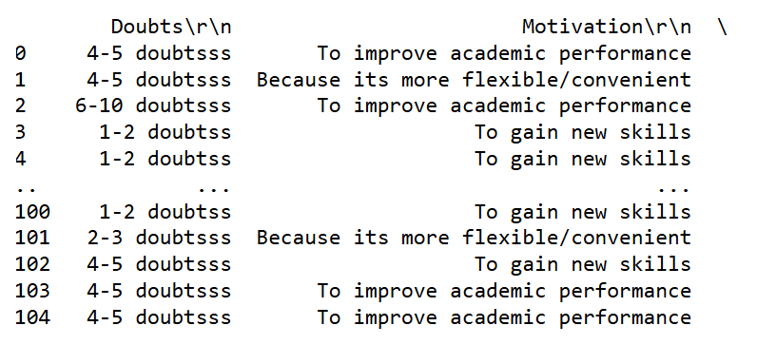

- Feature Engineering
21)Create a new column:Study_Intensity_Score= weekly_study_hours × number_of_courses
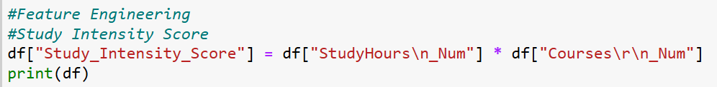
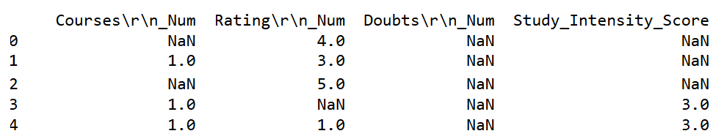

22)Create a binary column:High_Engagement
• Yes → study hours ≥ 21 and courses ≥ 4 • No → otherwise
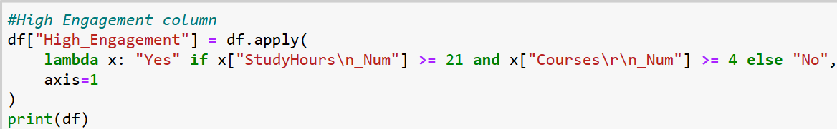
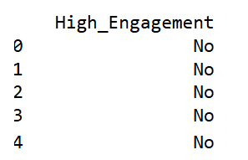

23)Create Satisfaction_Level categories:• Low (1–2) • Medium (3) • High (4–5)
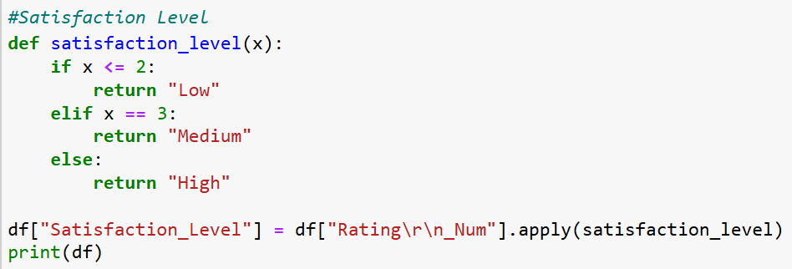
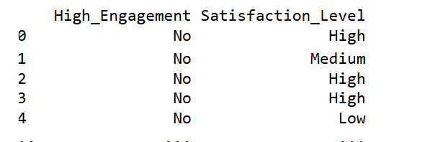

24)Create a column classifying Internet Quality as numeric:• Poor → 1
• Average → 2 • Good → 3
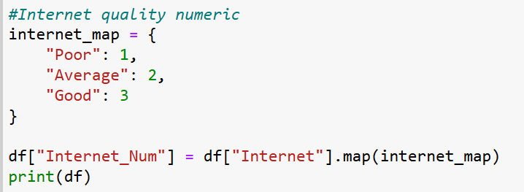
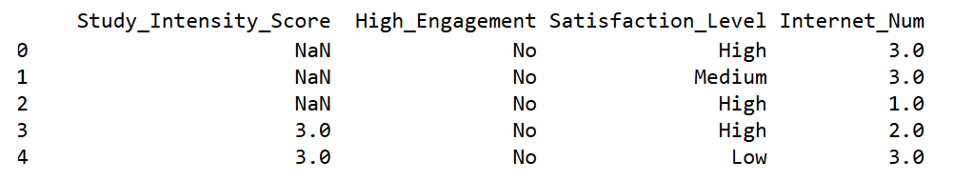

25)Create a column Active_Learner:• Yes → doubts ≥ 4 per week • No → otherwise
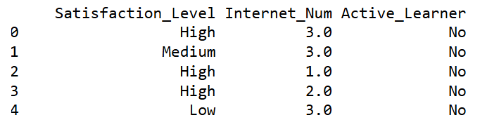

- Grouping & Aggregation
26)Find average weekly study hours by gender.
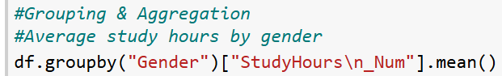
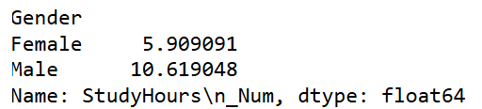

27) Find average course rating by learning platform.
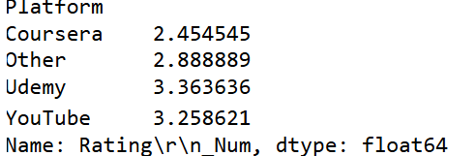

28)Group by subject preference and count respondents.
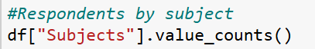
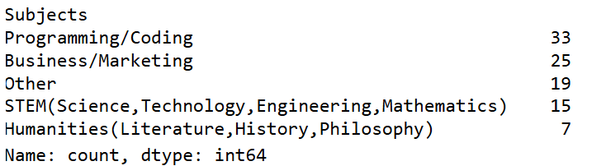

29)Find average number of doubts per week by type of learner.
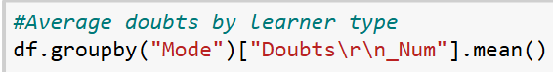
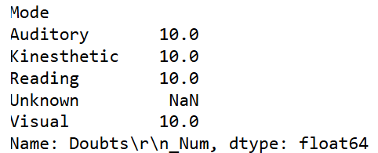

30)Group by age group and calculate average study hours.
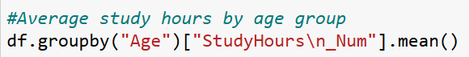
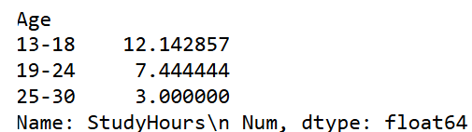

- ADVANCED–MODERATE QUESTIONS
- Time-Based Analysis
31) Convert Observation_Date into datetime format.
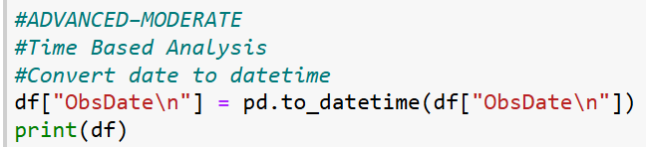
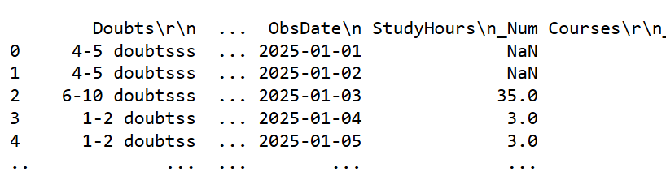
32)Find number of survey responses collected per day.
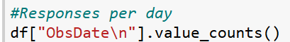
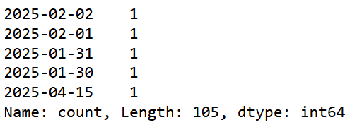

33)Identify the date with the highest number of high engagement learners.
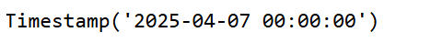

Correlation & Insights
34)Check correlation between:
• Weekly study hours and course rating
• Number of doubts and satisfaction rating
• Number of courses and study hours
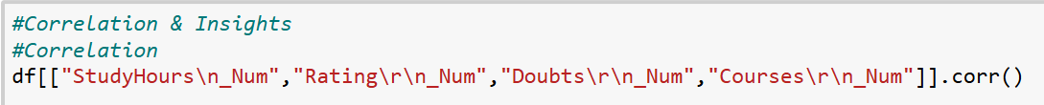
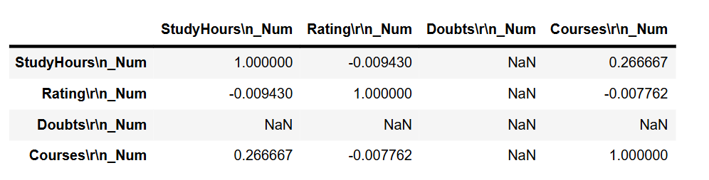

35) Does better internet access lead to higher satisfaction?
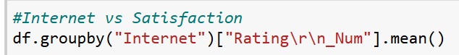
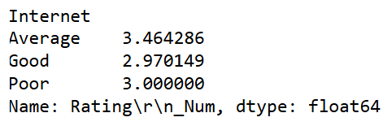

Conclusion
This analysis demonstrates that modern online learning is highly diverse. While platforms like YouTube dominate the landscape, the "one-size-fits-all" approach to study hours does not directly translate to student satisfaction. Factors such as Internet Quality and Doubt Resolution Methods play a more significant role in the learner's journey than simply the volume of study time.
The project highlights the importance of Feature Engineering in data science—turning text-based survey answers into numeric scores allowed us to uncover hidden trends that weren't visible in the raw CSV file.

